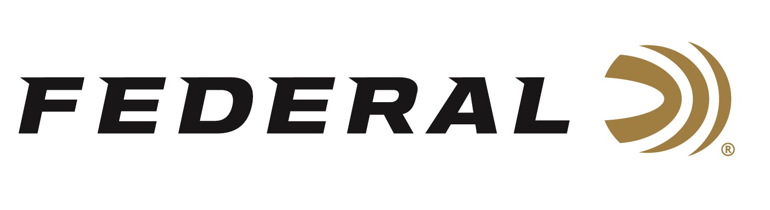

FOR IMMEDIATE RELEASE

Federal’s Sponsored Shooter Kayle Browning Wins Gold in Abu Dhabi

ANOKA, Minnesota – February 3, 2026 – Federal Ammunition congratulates Kayle Browning on her gold medal performance in Women’s Trap at the Abu Dhabi Shotgun Grand Prix held in the United Arab Emirates. The event took place at the Al Ain Equestrian, Shooting and Golf Club in Al Ain City and ran from January 22-31, 2026. The major event attracted 165 of the world’s best trap and skeet shooters from twenty-six countries.

Browning qualified for the final in Women’s Trap in the fourth position and with a perfect score in the final, she passed the field including Italy’s Jessica Rossi and Poland’s Sandra Bernal to win gold. “What a way to start off 2026,” said Browning, a 2020 Olympic silver medalist in Women’s Trap. The 33-year-old was a perfect 30/30 in the final. “I am incredibly grateful for this opportunity to compete again. This shoot exceeded any expectations I had,” continued Browning. “Being able to put into actions the things I have been practicing at home into a competition setting and have it pay off, is one of the most rewarding things as an athlete.

In the Men’s Skeet competition, four-time Olympic Champion Vincent Hancock finished with a bronze medal.

To support America’s shooting team, visit www.usashooting.org to find out more.

Federal Ammunition products are available at dealers nationwide and online. For more information on all Federal products and to sign up to receive notifications about new product availability, rebate promotions, and other brand news via email, visit www.federalpremium.com.

Press Release Contact: JJ Reich
Senior Manager – Press Relations
E-mail: media@tkghunt.com

About Federal Ammunition
Federal, headquartered in Anoka, MN, is an ammunition brand of The Kinetic Group, owned by CSG, a globally diversified industrial group based in Prague, Czech Republic. Since 1922, Federal has been a leader in ammunition innovation, delivering high-quality sporting and hunting products to shooters worldwide. With a commitment to conservation and the outdoor community, Federal continues to manufacture industry-leading ammunition that enhances the shooting experience while supporting outdoor traditions.

